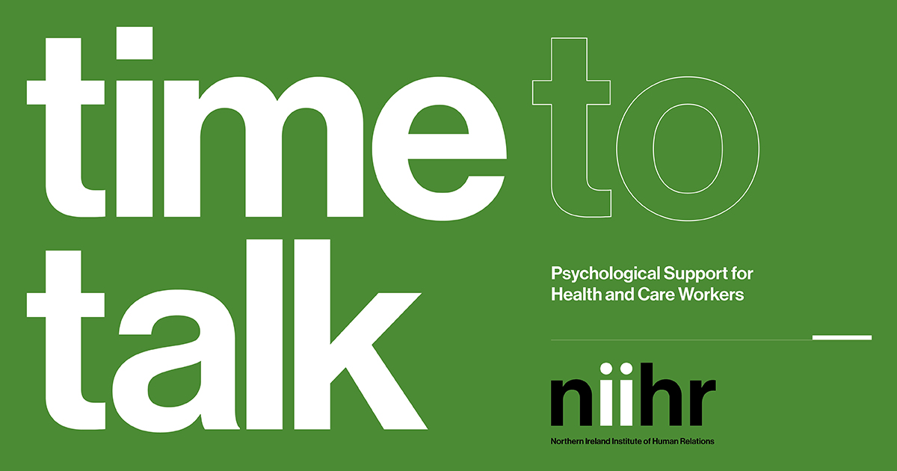
We all need help, at times, when it comes to our mental health. And there is very good support available here in Northern Ireland, with experienced and well-trained therapists, psychologists, counsellors, and mental health practitioners providing various forms of mental healthcare interventions, in the public, the voluntary, and the private sectors.

This is such a difficult and challenging time, for all of us, in which to be living and working. It’s a very unsettled and unsettling time, and particularly so for those who find themselves working in frontline health and social care settings through the current pandemic. It’s an experience which will inevitably take its toll in terms of mental as well as physical health, and for some people it will be vital to think about finding a secure setting in which to begin to address the psychological impact of their recent and ongoing experience.

One helpful route is to visit your GP to discuss your state of mind and to consider your mental health needs moving forward. Many GP surgeries have their own counsellors, and all GPs are in a position to assess the needs of patients and, where appropriate, to make onward referrals to psychotherapy, counselling, clinical psychology, and psychiatry. And listed below are a number of accredited counselling and therapy organisations, together with vital frontline and lifeline services.

It’s worth keeping in mind that different people find the various approaches to working with mental health more or less helpful - it’s quite a personal thing, what works for whom. Many people, for example, draw greatly from the shared experience which group therapy brings. And whilst it’s good to talk, certainly, talking isn’t necessarily for everyone - so you might want to think about creative arts therapies, like music and art therapy, expressive therapies, like dance movement psychotherapy, or the healthy, creative use of art, writing, dance, yoga, sport, and exercise, like swimming, walking, or running. It’s about finding what’s helpful for you. The capacities for playfulness, humour, creativity, self-expression, and kindness (very much including self-kindness) are all key when it comes to mental health.

Some Therapeutic Mental Health Resources in Northern Ireland

Frontline19 is a UK nationwide NHS service delivering supervision, debriefing and emotional support to healthcare workers during times of crisis. With a vast network of thousands of qualified therapeutic practitioners, we can ensure that healthcare workers get the right help quickly and easily It’s a free and confidential emotional support service:
https://www.frontline19.com/

The Northern Ireland Institute of Human Relations is a member organisation of both the Irish Council for Psychotherapy and the UK Council for Psycho-therapy. Institute members provide psychoanalytic and psychodynamic psychotherapy:
http://www.niihr.org/therapist-list

The Northern Ireland Psychoanalytic Society is a member organisation of the British Psychoanalytic Council. Members of the Society are rigorously trained psychoanalytic psychotherapists:
https://nipsychoanalyticsociety.com/psychotherapist-list

The British Association for Counselling and Psychotherapy has a register of counsellors and therapists working throughout Northern Ireland:
https://www.bacp.co.uk/search/Therapists

The British Psychological Society provides a directory of chartered psychologists offering various psychological services:
https://www.bps.org.uk/lists/DIR

Lifeline is the Northern Ireland crisis response helpline service for people who are experiencing distress or despair:
https://www.lifelinehelpline.info/

Links to Useful Resources
Click here to access some helpful mental health resources - including links to various articles, guidance, podcasts, and videos.

